**Spatiotemporal Assessment of Air Quality Effects Due to Industrial Activities and Urbanization in India**

**by**

Jacob Okello Okomo

*EGS2405 Mini Project report submitted to the department of Geomatic Engineering and geospatial Information Systems degree of Bachelor of Science in GIS 2021.*



**Department of Geomatic Engineering and Geospatial Information Systems (GEGIS)**

# Abstract

Urban population growth in Kenya XXXXX

# Table of contents

Abstract V

Table of contents VII

List of figures IX

List of tables X

Acronyms and abbreviations XI

1 Introduction - 1 -

1.1 Background - 1 -

1.2 Motivation and problem statement - 1 -

1.3 Research identification - 2 -

1.3.1 Research objectives - 2 -

1.3.2 Research questions - 2 -

1.4 Study outline - 3 -

2 Literature review - 5 -

3 Materials and methods - 7 -

3.1 Study area - 7 -

3.2 Data - 8 -

3.3 Methodology - 8 -

4 Results - 9 -

5 Discussion - 11 -

6 Conclusion and outlook - 13 -

References - 15 -

Appendix A

# List of figures

Figure 1: Example of a figure. It uses Tables & Figures Caption style in quick styles gallery. - 2 -

# List of tables

Table 1: Sample of a table. It uses Tables & Figures Caption style in quick styles gallery. - 2 -

# Acronyms and abbreviations

Add your acronyms here

# Introduction

## Background

Remove irrelevant sections/chapters as you use the template e.g., acknowledgements, Declaration etc.

However, the abstract is mandatory. I hope I am clear?

Thanks

The mini-project report should cover the following chapters with the details expounded with the following sections: There should be enough supporting references especially in the background and motivation and problem statement sections.

Elements of the introduction in a snapshot (follow the funnel approach).Motivation and problem statement

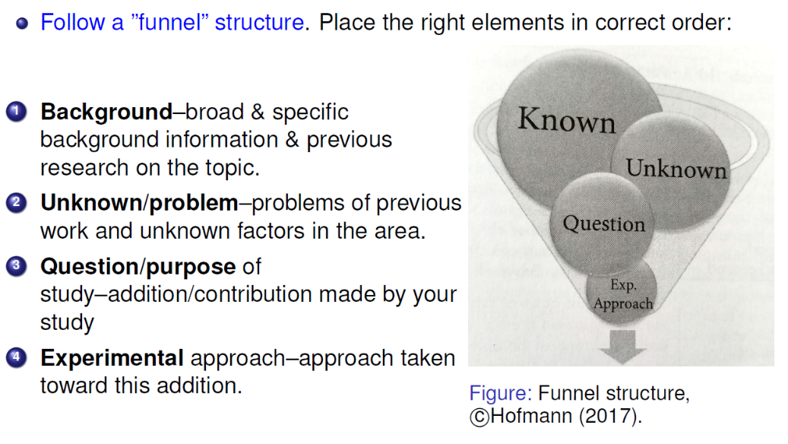

Table 1: Sample of a table. It uses Tables & Figures Caption style in quick styles gallery.

## Research Objectives

The main aim of this research is to assess spatiotemporal air quality impacts due to industrial activities and urbanization in India. This is achievable through the following specific objectives:

### Research objectives

1. To perform ESDA and descriptive statistics to assess the central tendency, shape and dispersion of the numerical variable.
2. To monitor the trend analysis of the air Quality index over time in the selected area of study.
3. To perform kriging interpolation to estimate values in unsampled variables

# Materials and methods

## Study area

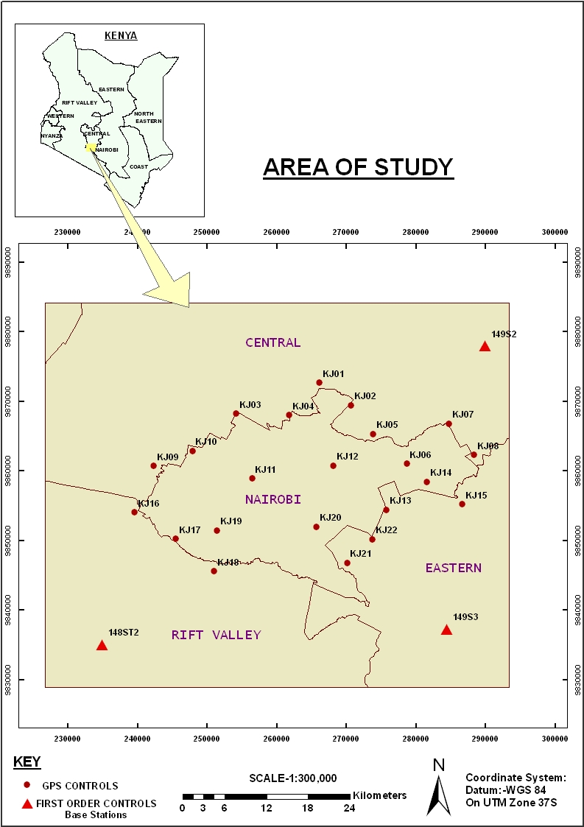

Figure 2: Example of a study area map

## Data

Describe the data used in the study.

## Methodology

Concisely describe the methodology used in your study.

Covering Study area, data, and a detailed description of methods used to implement the study's objectives. The aim of this chapter is to describe the experimental approach used to arrive at conclusions.  
1. Provide enough details and references to enable a trained scientist to evaluate or  
repeat your work. For example, state: Materials, subjects, design, and procedure.  
2. Include materials & methods but not results. The section is linked to results but they must not be discussed here.  
3. Provide literature references where needed, e.g., Plasmids were isolated according to Braun (2018).  
4. Include sufficient technical details to let others repeat your work.  
5. Use parenthesis for technical specifications. It ensures that coherence in writing is maintained.  
6. Indicate any statistical analysis performed. E.g., One-way analysis of variance was performed using the GLM procedure of SAS.  
7. Place full descriptions of procedures or other lengthy details in an appendix.

# Results

This chapter should describe the results obtained from each objective and methods in detail with support of tables, maps, and graphs where necessary. The elements of this chapter include:

1 Report your main findings as well as other important findings.  
2 Include control results. Explanations for point 1 & 2:-  
Report results pertinent to information provided in the introduction &  
experiments described in methods.  
Exclude preliminary results & other irrelevant results.  
In some cases preliminary results may be included in the Materials and Methods  
If need be, explain the aim of an experiment briefly before presenting results.  
Other key findings could be supportive evidence & other results meaningful  
for the paper even if they may not be part of the main story.  
3 Point the reader to the data shown in figures & tables.  
NB: Main findings should be stated in the text interpreting/describing the figures & tables.  
4 Interpret your data for the reader: Summarize & interpret the meaning of data for readers.  
5 Place statistical information with data. Do not use it instead of results.  
Interpret descriptive statistics for your readers.

# Discussion

This chapter should:

* State & interpret your key findings. Provide the answer to the research questions.
  + In the Discussion, provide the answer to the research question.
  + To do so, interpret your key findings & draw conclusions based on these findings in the context of the research topic and overall related fields.
  + Place your findings in the context of science. The discussion should explain how you arrived at your conclusion, compare and contrast your findings with existing knowledge on the topic, and state theoretical implications or practical applications.
  + This gives the paper significance by generalizing results while clearly indicating how your study has advanced knowledge.
* Summarize & generalize.
  + Explain what is new in your work & say why your results are important.
  + Include explanations for any results that do not support the answers and discuss other results and hypotheses that are relevant to yours.
  + In addition, you may discuss any possible errors or limitations in your methods, give explanations of unexpected findings, and indicate what the next steps might be.
  + Do not refer to every detail of your work again; repeating the Results section in the Discussion.
  + Instead, in your Discussion, summarize and generalize.
* Keep in mind who your potential readers will be.
  + Adjust the Discussion according to your potential reader and make it no longer than necessary.
  + Maintain the area of interest of the specific group of people you are targeting.
* Organize the Discussion in a pyramid structure.
  + Unlike the Introduction, which follows a funnel shape, the Discussion follows a pyramid shape.
  + i.e., it moves from specific to general.
  + 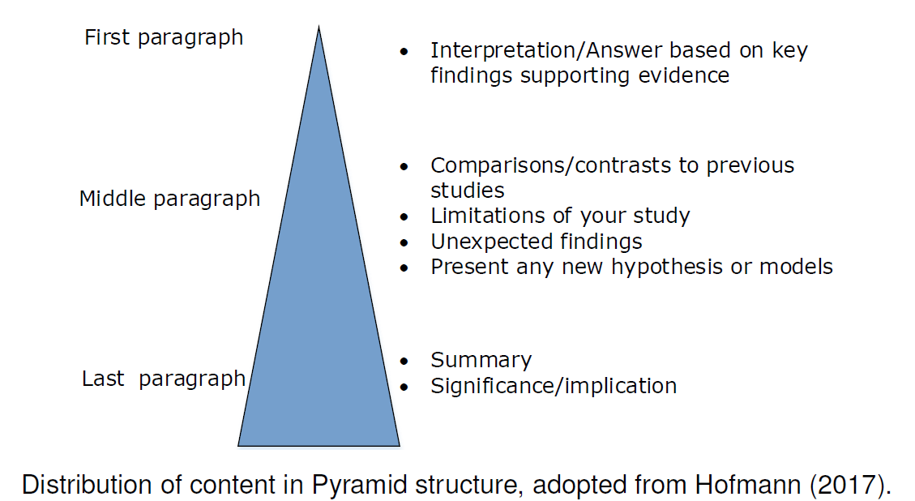

# Conclusion and outlook

Draw conclusion to your study in reference to results obtained and objectives of our study. In the same note provide recommendations to subsequent studies.

Conclude the study in regard to the mini-projects objectives and findings of the research.

# References

Provide an exhaustive list of references preferably using APA citation style. Be advised to use [Mendeley Desktop](https://www.mendeley.com/download-mendeley-desktop/) an open source reference manager software with MS Word plugin.